Keeping Hands to Myself

I will keep my hands to myself. I will have nice hands. I cannot touch things that are not mine. I cannot grab my teachers or my friends. I cannot hit. I cannot pull hair. I cannot touch the Smartboard. If I do not have nice hands, it makes my friends and my teachers sad. I will have nice hands. I will keep my hands to myself.

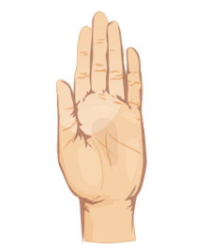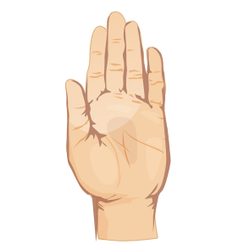

www.speechkidsfun.com