Saying “No” to Teachers

At school, my teachers want to help me. My teachers want to keep me safe and help me learn. I will listen to my teachers. I will follow directions. I will not say “no” to my teachers. My teachers want to help me and keep me safe. I will listen to my teachers.

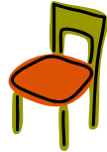

www.speechkidsfun.com